EXCESS (Underutilized) PROPERTY DESCRIPTION
December 5, 2015

The Department of Finance and Administrative Services, as the Jurisdictional Department of this City owned property has identified the following information about this excess property.

Property Name: PMA 92 – Department of Information Technology Communication Shop
98101 Latitude 47.618067, Long -122.332650

PMA | Parcel Size | Parcel # | Address | Zoning | 2015 Est Value | Legal Description
92 | 14,405 | 066000-2195 | 1933 Minor Ave | Downtown mixed Com. 240/290-400 | $12- $14 million | Lot 7 and 8, block 52, Sara Bells 2nd add to City of Seattle

Map: 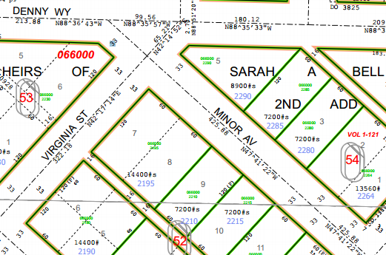

History:
The property was purchased in 1903. The current building was constructed in 1951, which included a room that was used for a radio shop. The building was used as fire station until 1972 when it was established as a communication shop to consolidate operations. The communication shop is operated by the City Department of Information Technology, (DoIT). The shop installs and repairs radio communications equipment for the Fire Department and Police Department and provides support for the City of Seattle portion of the regional 800 Mhz radio communication system.
The property is located in the Denny Triangle which is experiencing significant redevelopment. The adjacent and nearby properties are being redeveloped to multistory apartments and office buildings. The property is classified by the Department of Finance and Administrative Services as “Underutilized”

Ordinances:
Ord. 22938, 1/10/1910, An ordinance accepting a deed, executed on the 20th day of July1903, by Fredrick Gasch and Ann Gasch, his wife, to the City of Seattle, for Lots 7 & 8, Block 52, Sarah.A. Bell’s 2nd, Addition to the City laid off by the heirs of Sarah A. Bell, deceased.

Ord. 101478 , 10/17/1972, AN ORDINANCE authorizing the Superintendent of Buildings to establish in Fire Station No. 15 a centralized communications facility for use by the Department of General Services and making a reimbursable appropriation from the Emergency Fund and declaring the emergency therefor.

Acquisition Deeds:
1/20/ 1903, Deed, Deed from Fred Gasch and Wife to City of Seattle

Other Documents:
A letter from Jack Richards, Chief of Seattle Fire Department, releasing the former Fire Station 15 to the department of building department for reassignment

A letter to City Council August 9 1972 regarding allocation of funds and establishment of a centralized communication facility and relocating the communications from the fifth and Cherry garage and at from the Seattle Center

Acquisition Fund Source: General Funds

Jurisdictional Department’s estimated market value: $500- $800/sq.ft. or $7.2-11.52 million

Destination of funds upon sale: FAS’s initial recommendation is that the property be sold, with some proceeds being designated to fund the relocation of the DoIt Communication Shop.

Current easements, covenants and restrictions: None of record

Recommended easements, covenants and restrictions upon Transfer: None

Potential problems with property and possible measures to mitigate their recurrence: Age of property suggests that underground oil or fuel tank may have been present. An alternative location for the communications shop has not been located.

Neighborhood: Belltown / Downtown

Legal Description: Lots Numbered Seven (7) and Eight (8) in block Number Fifty-Two (52) of the Second Addition to the City of Seattle laid off by heirs of Sarah A. Bell, deceased, together with the appurtenances.

Building Information:
Building square footage 4,964 including a lower level basement storage area.
Constructed 1952 for use as fire station
Remodeled in 1972 for use as Communication shop
The building was structurally and mechanically updated in 1990
In 2002 a back-up generator was installed
In 2006 the heating and air conditioning system was updated.

Adjacent Property Owners:

Crescent Development
Modern Digital
1921 Minor Ave
Seattle, WA 98101
Parcel # 0660002210

Community Psych Clinic
Group Home
1930 Boren Ave
Seattle, WA 98101
Parcel # 0660002190

